**Portfolio Management Coursework**

**Fears investor sentiment and asset prices**

RUIZHE xia | Haoyu Dai | Ziying lin

imperial college London | Mathematics and Finance

2020

FEARS INVESTOR SENTIMENT AND ASSET PRICES

Abstract

In this report, we looked at the paper “The Sum of All FEARS Investor Sentiment and Asset Prices” by Zhi Da, Joseph Engelberg and Pengjie Gao. We use daily Internet search volume from millions of households to reveal market-level sentiment. By aggregating the volume of queries related to household concerns (e.g., “recession,” “unemployment,” and “bankruptcy”), we construct a Financial and Economic Attitudes Revealed by Search (FEARS) index as a new measure of investor sentiment. We try to reproduce the result in the paper and construct the FEARS again. The predictive power of out FEARS index was not as good as the authors’ result.

But beyond replication, we also tried several extensions in robustness check. We not only check the influence of the number of words selected, we also do experiments on index updating frequency. In the paper, the author suggested to update the component of the FEARS index every 6 months. In this coursework, we tried to improve our result by:

1. Try different updating frequency to see if higher frequency lead to better result.
2. Try construct Fears index by using weighted averaging rather than equal-weight averaging

After looking at the asset returns, we also tried to find the correlation between FEARS index and other asset classes other than equities. We also tried to work with fund flow to see how the market sentiments influence the investors’ appetites and how the money was channelled. Our finding is similar to the authors’ result, but our FEARS index was not as powerful as stated, partially because of the sub-optimal word selection and time effects.

**Contents**

Chapter 1: Index Construction 2

1.1 Create list of 111 interested words 2

1.2 Data downloading methodology 3

1.3 Data Cleaning and Pre-processing 3

Remove outliers and extreme movement: 3

Remove weekly and monthly seasonality: 4

Remove heteroscedasticity: 4

1.4 Identify the 30 most important term and merge into final index by averaging (6-month) 5

1.5 Construct other data: 5

Chapter 2: FEARS and Asset Returns 6

2.1 6-month updating frequency FEARS and average returns of SP500 6

2.2 Construct 6-month updating FEARS index with components weighted by frequency 9

2.3 Construct FEARS index with different updating frequency 10

Chapter 3: FEARS and returns of other asset classes 12

Chapter 4: FEARS and Fund Flows 13

# Index Construction

Throughout the project, we found the index construction was the most time-consuming step. We construct our index through following several steps

## Create list of 111 interested words

Our objective is to build a list of search terms that reveal sentiment toward economic conditions. In the introduction paper, we learned about how to extract, filter and organize data.

**Step 1:**

We follow the recent text analytics literature in finance, which uses the Harvard IV-4 Dictionary and the Lasswell Value Dictionary. These dictionaries place words into various categories, like “positive”, “ negative”, ”weak,””strong,””economic”. Our goal is to filter out economic words with positive and negative directions. The results we obtained are “gold”, “bankrupt”, ”oligarchy”, ”unemployed”and were built the “primitive” word list (150 words).

**Step 2:**

We input each primitive word into Google Trends, which, among other things, returns ten “top searches” related to each primitive word. For example, we searched the word “gold” and the results in the related searches “gold price,” “gold rate,” “gold coast,” “gold ring,” and “black gold” because this is how the term “gold” is commonly searched in Google. Our 150 primitive words generate 1,500 related terms, which become 1,453 terms after removing duplicates.

**Step 3:**

We removed terms with insufficient data and removed terms that are not clearly related to economics or finance. For example, search for “depression” results in the related searches “go bankrupt,” “bankruptcy,” “trump bankrupt,” “file bankruptcy,” “bankruptcy court,” “filing bankruptcy,” etc. We keep the first three terms (which relate to an economic bankruptcy) and remove the last three terms (which relate to computer bankruptcy). This leaves us with 120 search terms.

Because we do not have enough IP to download the related words, during the download process, our team spent 10 days, using 4-5 kinds of codes to express, running on Google Colab, but was intercepted and cooled by Google. Therefore, we did not get the same effect as the author by using the “introduction paper” method.

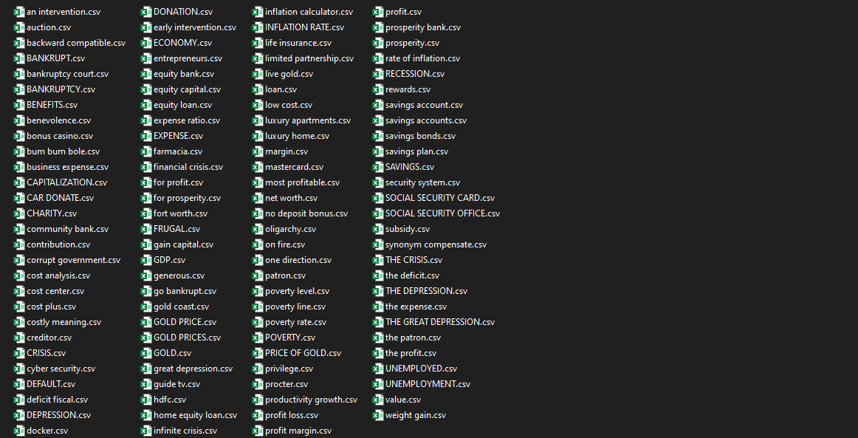

## Data downloading methodology

We are working with python “pytrends” API to download daily work search frequency data directly from the google website.

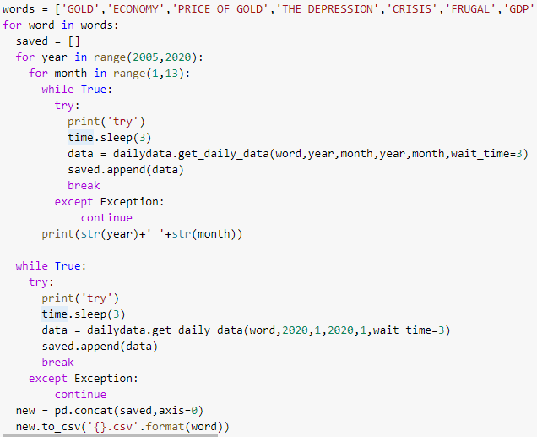The first problem we were facing was the way of downloading daily data. Google automatically select frequency for the users. If we want to download 15 years directly, google will force user to download monthly data. Hence, in order to get daily search frequency data, we need to constantly send downloading request on each month and then merge them manually.

The second problem was the upper limit of the number of downloading requests that google is imposed to all python user. We need to constantly create new python agent to bypass the weekly requesting limits and to avoid blacklist of IP address.

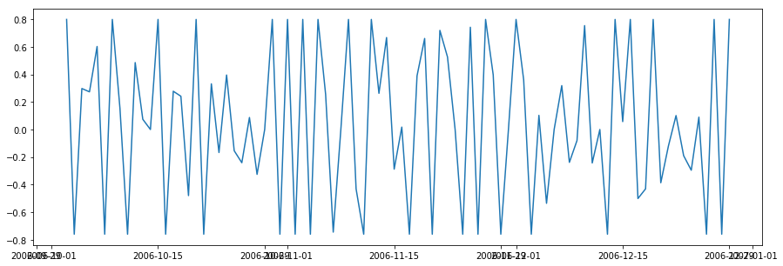We save each word as an independent csv file in the folder **“111_google_trends”**. Finally, after all the 111 words was downloaded, we merge the data together to form our final dataset **“111_daily_trends.csv”**. These files contain the original unprocessed daily google search frequency for all the 111 interested words. The image below shows the daily frequency percentage change of the search item “Price of gold”

## Data Cleaning and Pre-processing

The data need to be processed for the following several steps in order to improve index accuracy：

### Remove outliers and extreme movement:

There is a situation where the search volume yester day is only 1 and the next day is 12 which makes the movement too extreme. We need to winsorize at 5% level at every time series (2.5% in each tail of every 111 words)

### Remove weekly and monthly seasonality:

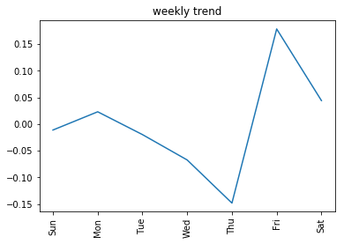 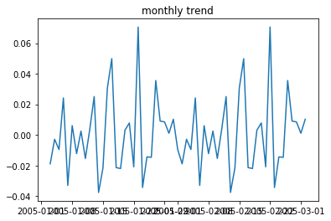There is a weekly trend where people tends to research more on weekends and less on weekday because people have more free time to use the internet in weekends than in working day. Hence the search volume change in this context will have no realistic meaning. Hence, we need to we regress search volume change on weekday dummies and month dummies and only keep the residual.

### Remove heteroscedasticity:

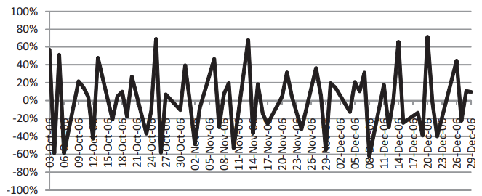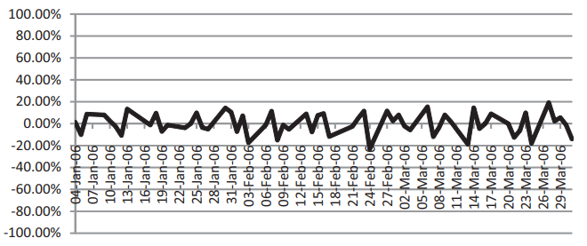Finally, to address heteroscedasticity and make each times-series comparable, we standardize each of the time series by scaling each by the time-series standard deviation as in Baker and Wurgler (2006). The image below shows how different words have different level of percentage change. Heteroscedasticity do exist.

This leaves us with an adjusted (winsorized, deseasonalized, and standardized) daily change in search volume, , for each of our 118 terms.

## Identify the 30 most important term and merge into final index by averaging (6-month)

First of all, we first create FEARS index with components that are updated every 6 month. For example, at the end of June 2009, we run a **regression** of on contemporaneous market return (SP500 return) during the period January 1, 2004 to June 30, 2009, for each of our 118 search terms. Then we rank the t-statistic on from this regression from most negative (i =1) to most positive (i =118). We select the thirty most negative terms and use these terms to form our FEARS index for the period from July 1, 2009, to December 31, 2009.

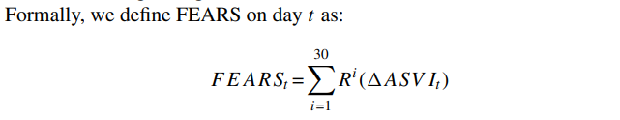

is the change in search volume of each word. And we average over the percentage change of 30 selected word. represents the most negative word. And then we could form the final FEARS index.

## Construct other data:

We also included The Chicago Board Options Exchange (CBOE) daily market volatility index (VIX), a high-frequency measure of concurrent macroeconomic conditions from the Federal Reserve Bank of Philadelphia and a news-based measure of economic policy uncertainty (EPU) recently developed by Baker.

And this is out final dataset:

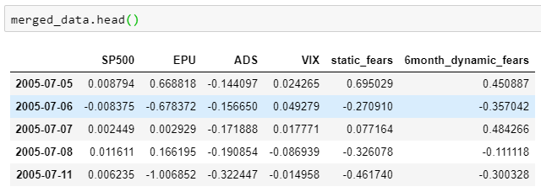

# FEARS and Asset Returns

We first examine the relationship between FEARS and returns across various asset classes. We then examine how this relationship varies when we consider different index updating frequency.

## 6-month updating frequency FEARS and average returns of SP500

We look for evidence of return reversals by running the following regressions:



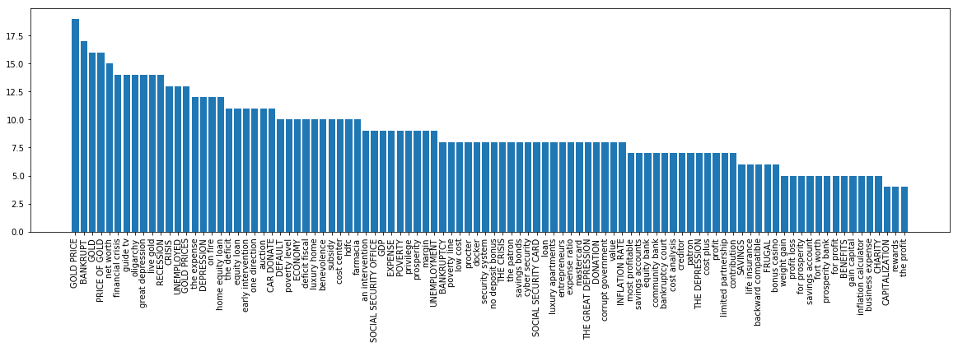Where denotes the asset I’s return on day , and we consider Control variables () include lagged asset-class returns, changes in a news-based measure of economic policy uncertainty (EPU), the CBOE volatility index (VIX), and changes in the Aruoba-Diebold-Scotti (ADS) business conditions index. We calculate bootstrapped standard errors, and our statistical inference is conservative. We found that the followinf words are used to contruct FEARS index and they have significantly different frequency. The word with more used frequency are more powerful in predicting the asset returns.



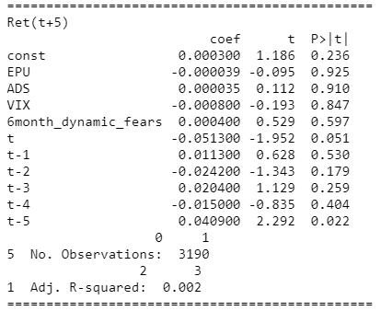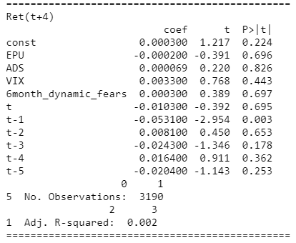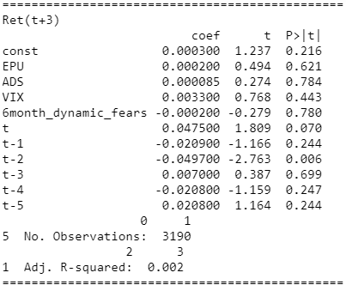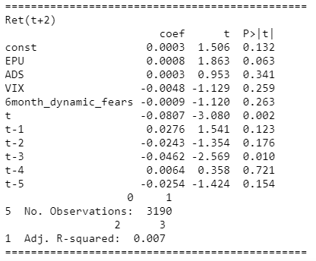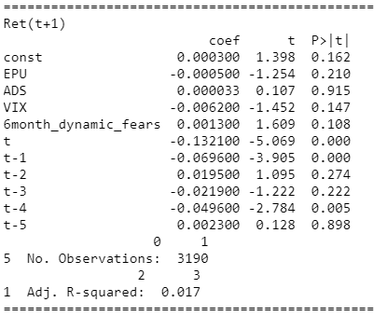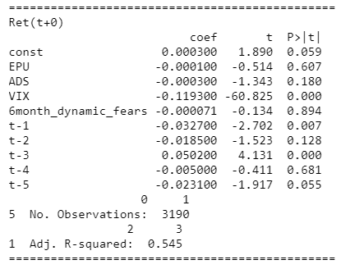And the regression result is below：

Similar to what is written by the author the search terms that compose the FEARS index were selected based on their historical correlation with the market. The first table suggests that they continue to be correlated out of sample when k=0. But in our cases, none of the cases above shows that the FEARS index is significant in predicting the future market return. The problem may comes from the word selected for constructing the FEARS index. This shows FEARS index is very sensitive to the pool of the 100+ candidate words that are used to construct the index.

But on the other hand, our FEARS index successfully reconstruct the change in fund flow which proves the inefficient market hypothesis, where the investor tends to overreact to bad news. Hence, we see a negative correlation in at k=0 (the first table), which means the investor search more negative words, the market is less confident and people tends to sell which leads to drop in price. Then on the day after, at k=1, the market realised it is overreacted and hence buy some shares buy which push up the price again. That why the coefficient of fears is negative in the first day and the negative in the second day.

Of course, such a short-term reversal can also be caused by a liquidity shock as in Campbell, Grossman and Wang (1993; GSW hereafter). As Baker and Stein (2004) point out, as sentiment and liquidity are intertwined, the difference between a sentiment-based story as in DSSW and a liquidity-based story as in GSW boils down how we view liquidity shocks and noise traders. Tetlock (2007) even goes so far as to say that “the difference between DSSW and CGW is philosophical rather than economic.” Our results remain interesting even under the liquidity interpretation, as they suggest high-frequency investor sentiment, as measured by our FEARS, can be a powerful trigger of a liquidity shock.

As a result, we may conclude that our FEARS index though reveals the relation between market sentiments and stock returns, but non of our regression is significant in predicting future returns. The reason may be:

1. Our 111 words selected for constructing the fears index as not as powerful as the author’s ones
2. The predictive power of google search sentiments are less significant now.

Hence, we proposed two possible **improvements** showing in the next section.

## Construct 6-month updating FEARS index with components weighted by frequency

Previously, the FEARS index was constructed by averaging all search terms with equal weights despite some word may appears more frequently and hence more powerful than others. Hence, the new formula is

Where all other terms remains the same and represents the weight of this word and represent the frequency word appears throughout the 15 years from 2005 to 2020. And then I run the same regression and got the following:

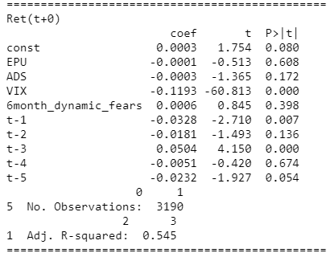 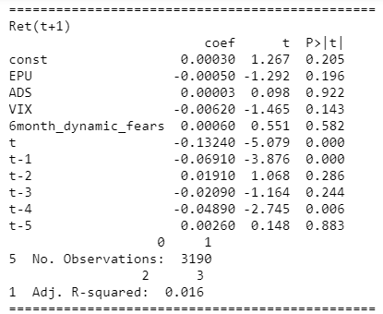 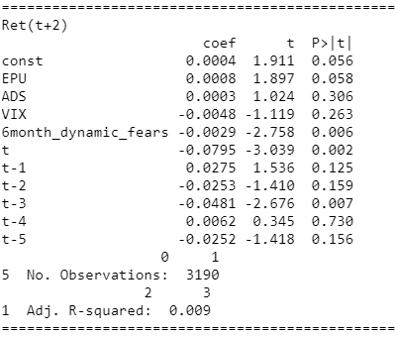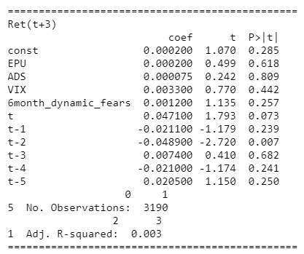

We could see that the result was actually worse and it even fails to show the negative relation between the returns and the Fears index. Hence, we decide this is not a great approach.

## Construct FEARS index with different updating frequency

In the paper, author updates the FEARS index every 6 month to decide the component for next 6 months. Here we decide to investigate how the t-value and the words chosen were changed when we pick different updating frequency.

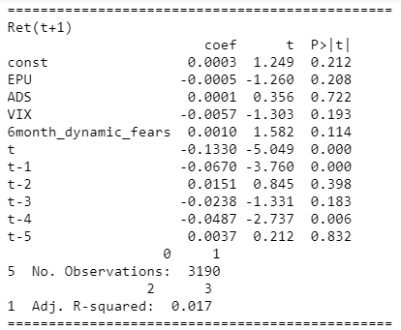**One-month frequency:**

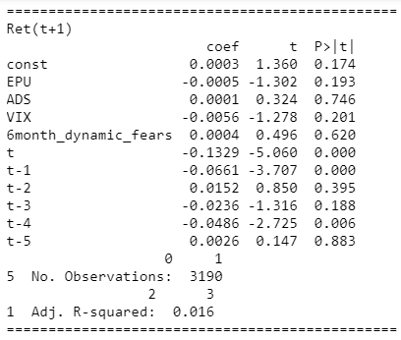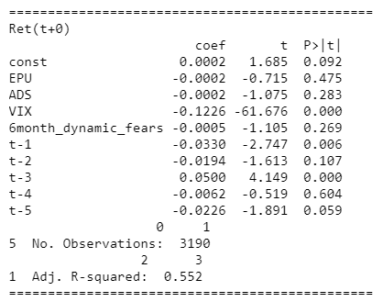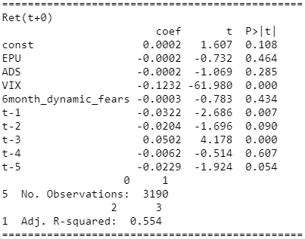 **Three-month Frequency**

**One-year Frequency**

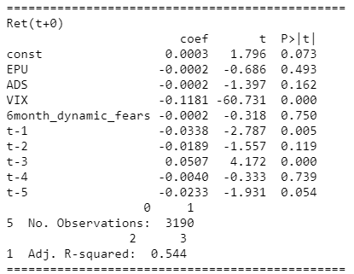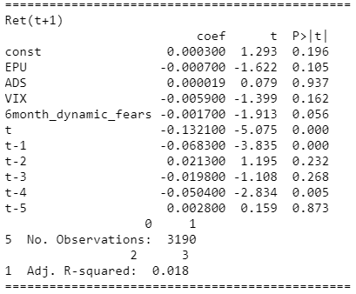

**One-month frequency:**

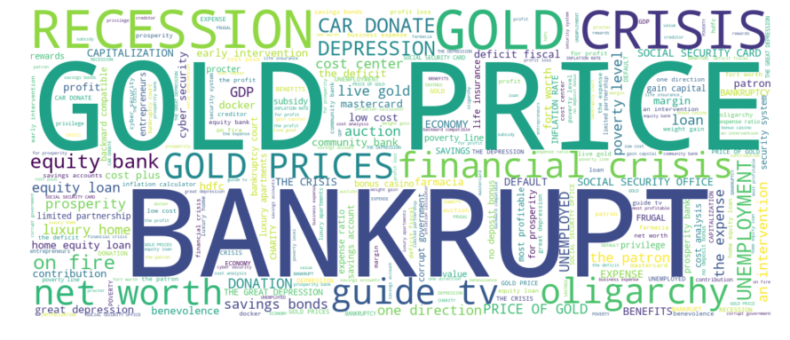**Three-month frequency**:

**One-year frequency**

We could see that 3-month updating frequency FEARS index has better performance than 6-month and 1-year updating frequency FEARS index, we may conclude that higher frequency do leading to better prediction result. However, the prediction improvement is still very limited. One of the reasons is that the word we choose are largely unchanged no matter which frequency we picked.

# FEARS and returns of other asset classes

In this section we will study the relationship between FEARS index and returns of other asset classes such as ETF. We obtained ETF daily data from “cn.investing.com” (Investing.com - Stock Market Quotes & Financial News, 2020). Similar to the previous sections, we chose the FEARS update frequency to be 6 months and perform regression on different datasets.

Panel A: Fears and SPY

|  |  |  |  |  |
| --- | --- | --- | --- | --- |
|  | Return(t) | Return (t+1) | Return (t+2) | Return (t+3) |
| FEARS | 0.0003 | -0.0003 | -0.0002 | 0.0003 |
| FEARS (p-value) | 0.061 | 0.774 | 0.836 | 0.127 |
| Control | -0.016 | -0.023 | -0.018 | -0.0004 |
| Yes | Yes | Yes | Yes |
| Control (p-value) | 0.284 | 0.352 | 0.231 | 0.4366 |
| Observations | 3190 | 3190 | 3190 | 3190 |
| Adjusted | 0.547 | 0.015 | 0.01 | 0.002 |

Panel B: Fears and IWB

|  |  |  |  |  |
| --- | --- | --- | --- | --- |
|  | Return (t) | Return (t+1) | Return (t+2) | Return (t+3) |
| FEARS | 0.0003 | 0.0003 | 0.0003 | 0.0003 |
| FEARS (p-value) | 0.052 | -0.019 | 0.104 | 0.192 |
| Control | -0.013 | -0.014 | -0.014 | -0.002 |
| Yes | Yes | Yes | Yes |
| Control (p-value) | 0.278 | 0.295 | 0.248 | 0.454 |
| Observations | 3190 | 3190 | 3190 | 3190 |
| Adjusted | 0.553 | 0.011 | 0.007 | 0.002 |

Panel C: Fears and IWM

|  |  |  |  |  |
| --- | --- | --- | --- | --- |
|  | Return (t) | Return (t+1) | Return (t+2) | Return (t+3) |
| FEARS | 0.0003 | 0.0003 | 0.0003 | 0.0003 |
| FEARS (p-value) | 0.113 | 0.292 | 0.198 | 0.278 |
| Control | -0.162 | -0.191 | -0.087 | -0.078 |
| Yes | Yes | Yes | Yes |
| Control (p-value) | 0.271 | 0.375 | 0.420 | 0.597 |
| Observations | 3190 | 3190 | 3190 | 3190 |
| Adjusted | 0.485 | 0.008 | 0.004 | 0.002 |

Table 1 FEARS and returns of other asset classes

From the Panel A table, we see that FEARS index is significant and has positive correlation with SPY return when k=0. However, for k>0, FEARS index becomes less significant.

From the Panel B table, we see that FEARS index is significant and has positive correlation with IWB for most of k. This shows that IWB is more affected by FEARS index and its component words.

Panel C table shows similar result as Panel A table. FEARS index is significant and has positive correlation with IWM return when k=0. However, for k>0, FEARS index becomes less significant. This make sense since IWM has higher expense ratio, thus riskier than IWB. Investors of IWM are less risk adverse so they tend to not affected by FEARS words.

# FEARS and Fund Flows

In this section, we studied the relationship between FEARS index and Fund Flows. Asset prices are affected by trading. We obtained mutual fund flow data from YCharts (YCharts, 2020) for mutual funds including US Mutual Fund, US Bond Mutual Fund and US Equity Mutual Fund.

There is one data issue. We were only able to obtain monthly data rather than daily data. Hence, we used linear interpolation to fill missing values for each month. However, since we have many missing values, we expected the result to be less accurate. We run the following regression:

where fund class i includes bond and equity funds. Control variables () include as usual VIX, △EPU, △ADS, and five lags of market returns. The results of these regressions are reported in Table 2.

Panel A: US Mutual Fund Flows

|  |  |  |  |  |
| --- | --- | --- | --- | --- |
|  | Flow(t) | Flow(t+1) | Flow(t+2) | Flow(t+3) |
| FEARS | 0.000039 | -0.0003 | -0.0002 | -0.0005 |
| FEARS (p-value) | 0.969 | 0.774 | 0.836 | 0.656 |
| Control | 0.0719 | 0.06475 | 0.05224 | 0.04572 |
| Yes | Yes | Yes | Yes |
| Control (p-value) | 0.2122 | 0.1833 | 0.2845 | 0.2124 |
| Observations | 3190 | 3190 | 3190 | 3190 |
| Adjusted | 0.299 | 0.298 | 0.171 | 0.117 |

Panel B: US Bond Fund Flows

|  |  |  |  |  |
| --- | --- | --- | --- | --- |
|  | Flow(t) | Flow(t+1) | Flow(t+2) | Flow(t+3) |
| FEARS | -0.0004 | -0.0005 | -0.0004 | -0.0006 |
| FEARS (p-value) | 0.801 | 0.788 | 0.819 | 0.727 |
| Control | 0.0321 | 0.0305 | 0.0326 | 0.0277 |
| Yes | Yes | Yes | Yes |
| Control (p-value) | 0.2767 | 0.3412 | 0.3138 | 0.2984 |
| Observations | 3190 | 3190 | 3190 | 3190 |
| Adjusted | 0.037 | 0.037 | 0.023 | 0.014 |

Panel C: Equity Mutual Fund Flows

|  |  |  |  |  |
| --- | --- | --- | --- | --- |
|  | Flow(t) | Flow(t+1) | Flow(t+2) | Flow(t+3) |
| FEARS | -0.0003 | 0.000061 | -0.0002 | 0.000013 |
| FEARS (p-value) | 0.748 | 0.952 | 0.882 | 0.990 |
| Control | 0.068 | 0.062 | 0.053 | 0.046 |
| Yes | Yes | Yes | Yes |
| Control (p-value) | 0.238 | 0.156 | 0.193 | 0.117 |
| Observations | 3190 | 3190 | 3190 | 3190 |
| Adjusted | 0.205 | 0.206 | 0.13 | 0.093 |

Table 2 Sentiment and Fund flows

We found that our FEARS index has less significant incremental predictive power for future daily fund flow of US Mutual Fund, US Bond Mutual Fund Flows and US Equity Mutual Fund Flows.

From Panel A, we see that the coefficient on FEARS is statistically insignificant for days t + 1 (p-value > 10%), t + 2 (p-value > 10%) and t + 3 (p-value > 10%) in the US Mutual Fund Flows regressions. However, coefficients are all negative, which shows that investors tend to withdraw from US Mutual Fund after they saw jumps in FEARS, and such an outflow persists for the next two days.

From Panel A, we see that the coefficient on FEARS is negative on each day we consider (t = 0, 1, 2, 3, and 4) and is not statistically significant for days t + 1 (p-value >10%), t + 2 (p-value > 10%) and t + 3 (p-value > 10%). Similar to US Mutual Fund, investors withdraw from US Bond Fund after jumps in FEARS.

In the US Mutual Equity Fund Flows regressions, the coefficient on FEARS is statistically insignificant. We don’t see clear correlation between US Mutual Euiqty fund flow and FEARS index. The table shows random trend regression coefficients.

**From below are the codes we used for our entire projects.**